

FACULTY OF INFORMATION AND COMMUNICATION TECHNOLOGY

COMP 101 – INTRODUCTION TO COMPUTER SKILLS

Title : Individual Assignment
Issue Date : Week 2
Due Date : Week 4
Lecturer/Examiner : Mr. Elijah Laggah
Name of Student : Crispin David Kamara
Student ID No. : 905006042
Class : BSEM 1101F
Semester/Year : 1/1

Academic Honesty Policy Statement

We, hereby attest those contents of this attachment are my own work. Referenced works, articles, art, programs, papers or parts thereof are acknowledged at the end of this paper. This includes data excerpted from CD-ROMs, the Internet, other private networks, and other people’s disk of the computer system.

Student’s Signature: Date: 30th October, 2026.
LECTURER’S COMMMENTS/GRADE:

for office use only upon receive
Remark

DATE :
TIME :
RECEIVER’S NAME :

1. Introduction
Transportation is an important part of everyday life in Sierra Leone because students, workers, traders, patients and businesses depend on roads and public transport to move people and goods. However, transport users can experience delays caused by traffic congestion, road conditions, vehicle breakdowns, overcrowding and limited information about alternative routes. These challenges can waste time, increase travel costs and make movement less predictable.
This project proposes a Community Transportation Management and Route-Reporting System (CTM-RRS). The system is a logical computer-based solution that allows users to report transport problems and receive a simple route or travel-status recommendation based on the information provided. The project focuses on problem solving through computational thinking, algorithm design, pseudocode, decision structures, repetition and modular design rather than full source-code implementation.

2. Problem Description and Background

2.1 Problem Description
A common transportation problem in Sierra Leone is difficulty knowing the current condition of a route before travelling. A road may be congested, blocked, damaged, affected by an accident, or experiencing a vehicle-related delay. Without timely information, commuters may continue toward a difficult route instead of considering another available option.
The proposed system addresses this problem by collecting simple reports from transport users. Each report can contain the route or location, type of problem, estimated severity and time of the report. The system processes the information and classifies the route condition as Normal, Moderate Delay or Severe Delay. It then provides an appropriate message to the user.

2.2 Background
Transportation challenges affect mobility, productivity and access to education, healthcare and economic activities. In busy urban areas, congestion and unexpected road problems can make journey times difficult to predict. A simple community reporting system can improve access to information by allowing people who are already travelling on a route to share useful observations.
The proposed solution is designed as an educational programming-logic project. It demonstrates how a real community problem can be converted into inputs, processing steps, decisions, outputs and reusable modules.

2.3 Who Is Affected
- Students travelling to school or university.
- Workers travelling to and from workplaces.
- Passengers using buses, poda-podas, taxis and other public transport.
- Drivers and commercial transport operators.
- Traders and businesses that depend on reliable movement of people and goods.
- Emergency and service users who need timely route information.

2.4 Why the Problem Exists
- Limited access to timely route-condition information.
- Unexpected congestion and road incidents.
- Road maintenance or temporary blockage.
- Vehicle breakdowns and transport delays.
- High dependence on busy routes.
- Lack of a simple centralized community reporting process.

2.5 Proposed Solution
The Community Transportation Management and Route-Reporting System (CTM-RRS) will provide a simple process for submitting and processing route reports. A user enters a route/location, problem type, severity and time. The system checks whether the information is complete, evaluates the severity, classifies the route condition, and produces a travel-status message. Reports can also be stored for monitoring and future analysis.

2.6 Community Impact
The proposed system could help commuters make better-informed travel decisions by giving them a simple indication of route conditions. It could reduce uncertainty, encourage community participation and create a structured record of reported transportation problems. It is not intended to replace traffic authorities or professional emergency services; rather, it demonstrates how basic computing logic can support community transportation information.

2.7 Objectives
- Collect basic transportation-condition reports.
- Validate required information before processing.
- Classify route conditions using clear decision rules.
- Provide a simple travel-status recommendation.
- Store reports for monitoring and future analysis.
- Demonstrate computational thinking and programming logic.

3. Computational Thinking Process

3.1 Decomposition
The transportation problem is divided into smaller tasks: collecting a report, validating the information, identifying the problem type, evaluating severity, classifying the route, producing a recommendation and storing the report.

3.2 Pattern Recognition
Repeated transportation problems can be grouped into patterns such as congestion, road blockage, road damage, accident-related delay and vehicle breakdown. Similar severity levels can also be handled using the same decision rules.

3.3 Abstraction
The system does not need every detail about a journey. It focuses on essential information such as route, problem type, severity and time. Unnecessary details are ignored so the main logic remains simple.

3.4 Algorithmic Thinking
The solution follows a logical sequence: receive input, validate it, process the severity and problem type, classify the route, produce an output and store the report. Decision statements are used when different conditions require different actions, while repetition can be used when several reports need to be processed.

4. Algorithm Design
Algorithm: Community Transportation Route-Reporting and Status System
- Start the system.
- Ask the user to enter the route or location.
- Ask the user to select the transportation problem type.
- Ask the user to enter the severity level.
- Ask the user to enter the report time.
- Check whether all required information is provided.
- If required information is missing, display an error message and request the missing information.
- If severity is Low, classify the route as Normal/Minor Delay.
- If severity is Medium, classify the route as Moderate Delay.
- If severity is High, classify the route as Severe Delay.
- Generate a travel-status recommendation based on the classification.
- Store the report.
- Display the report status and recommendation.
- Ask whether another report should be processed.
- If Yes, repeat the reporting process.
- If No, end the system.

4.1 Variables, Constants and Data Types
Name | Type | Purpose | Example
routeLocation | String | Stores route/location | Wilberforce Road
problemType | String | Stores problem | Traffic congestion
severity | Integer | Severity level | 1, 2 or 3
reportTime | Time/String | Report time | 08:30
routeStatus | String | Calculated status | Moderate Delay
recommendation | String | Travel advice | Use an alternative route
anotherReport | Boolean | Controls repetition | Yes/No

5. Pseudocode
The following pseudocode represents the main logic of the proposed transportation system:
BEGIN

DISPLAY "Community Transportation Route-Reporting System"

INPUT routeLocation
INPUT problemType
INPUT severity
INPUT reportTime

IF routeLocation is empty OR problemType is empty OR severity is empty THEN
DISPLAY "Please provide all required information"
ELSE
IF severity = 1 THEN
routeStatus = "Normal / Minor Delay"
recommendation = "Travel normally but remain alert"
ELSE IF severity = 2 THEN
routeStatus = "Moderate Delay"
recommendation = "Expect delays and consider another route"
ELSE IF severity = 3 THEN
routeStatus = "Severe Delay"
recommendation = "Avoid the route if an alternative is available"
ELSE
DISPLAY "Invalid severity level"
END IF

STORE routeLocation, problemType, severity, reportTime,
routeStatus and recommendation

DISPLAY routeStatus
DISPLAY recommendation
END IF

INPUT anotherReport

WHILE anotherReport = "Yes"
Repeat the reporting and processing steps
INPUT anotherReport
END WHILE

DISPLAY "Thank you for using the system"

END

6. Logical Design

6.1 Input
Route/location, transportation problem type, severity level, report time and the user's choice to submit another report.

6.2 Processing
The system validates the information, evaluates severity, determines the route status, creates a recommendation and stores the report.

6.3 Output
Validation message, route condition/status, travel recommendation and stored-report confirmation.

6.4 Decision Structures
IF, ELSE IF and ELSE structures determine the route status. Low severity produces a normal/minor-delay status, medium severity produces moderate delay, and high severity produces severe delay.

6.5 Repetition Structures
A WHILE loop allows the user to submit more than one transportation report without restarting the system.

6.6 Functions
- collectReport() – collects route, problem, severity and time.
- validateReport() – checks required information and valid severity.
- classifyRoute() – determines route condition.
- generateRecommendation() – produces travel advice.
- saveReport() – stores the report.
- displayStatus() – displays the result.

6.7 Modular Design
The system is divided into modules so each part has one main responsibility. This makes the logic easier to understand, test, maintain and improve.

7. Flowchart
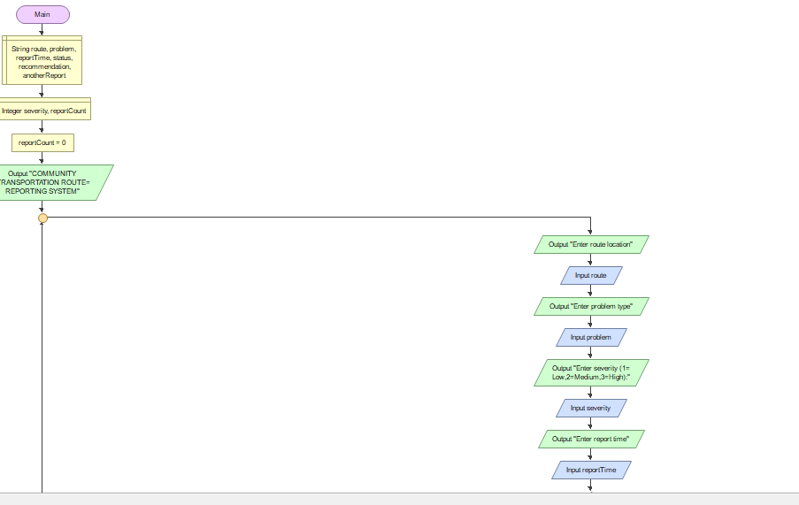

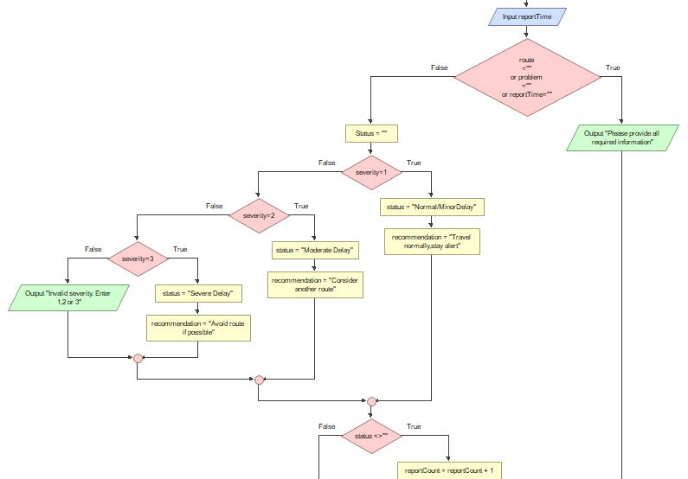

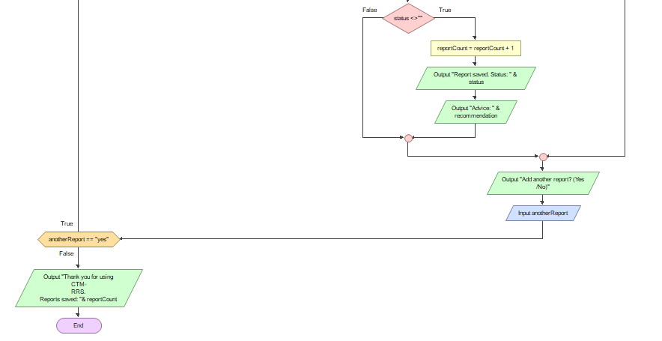

8. Functional Modules
Module | Main Function | Output
Report Input Module | Collects route, problem type, severity and time. | Completed report data
Validation Module | Checks required information and severity. | Valid/invalid message
Classification Module | Evaluates severity and classifies route. | Route status
Recommendation Module | Generates travel advice. | Recommendation
Storage Module | Stores processed report. | Saved report
Display Module | Shows status and recommendation. | User result

9. Expected Outputs and Sample Scenarios

Scenario 1: Low Severity
Severity = 1. Output: Normal / Minor Delay – Travel normally but remain alert.

Scenario 2: Medium Severity
Severity = 2. Output: Moderate Delay – Expect delays and consider another route.

Scenario 3: High Severity
Severity = 3. Output: Severe Delay – Avoid the route if an alternative is available.

Scenario 4: Missing Information
Missing route or severity. Output: Please provide all required information.

10. SDG Alignment
The project aligns mainly with Sustainable Development Goal 11: Sustainable Cities and Communities. SDG 11 promotes safer, more inclusive, resilient and sustainable cities and communities. A community transportation information system can support the general goal of improving urban mobility and helping people access useful information about movement within their communities.The project can also relate to SDG 9, Industry, Innovation and Infrastructure, because it demonstrates how digital technology and information systems can be used to address infrastructure and mobility challenges.

11. Open Source Software Justification
The project can be developed or extended using open-source tools and technologies. Open-source software can support learning because students can inspect, use and improve available tools without depending entirely on proprietary software. For this academic prototype, open-source or freely available development and diagramming tools can reduce barriers to experimentation and collaboration.

12. Digital Public Good Justification
The proposed transportation reporting concept can contribute to the idea of a Digital Public Good because it is designed around a community need and could potentially be made openly available for public benefit. To qualify formally as a Digital Public Good, a real implementation would need to meet the applicable Digital Public Goods Standard and its requirements. Therefore, this assignment presents the project as a concept that could be developed toward those principles rather than claiming formal certification.

13. Sustainability and Future Improvements
The system could be improved by connecting it to maps, adding verified reports, providing administrator review, recording historical congestion patterns and supporting notifications. Future versions could include transport operators, emergency contacts and route comparison. These improvements would require additional technical design, data protection measures and reliable data sources.For sustainability, the system should use clear data structures, modular functions and maintainable documentation. Community participation and appropriate verification would also be important because inaccurate reports could lead to poor travel decisions.

14. GitHub Evidence
Create a GitHub repository using a clear name such as PROG101_Assignment1_StudentName_StudentID. Upload the final Word report and any required supporting files. Add a README describing the project, problem, proposed solution and files in the repository. Include the repository URL and screenshots of the repository/commit history where required.
GitHub Repository URL: ______________________________________________
Repository Screenshot: [INSERT SCREENSHOT HERE]
Commit History Screenshot: [INSERT SCREENSHOT HERE]

15. Conclusion
Transportation problems such as congestion, route blockage and unexpected delays can make movement difficult for community members. This project demonstrates how programming logic can be used to design a simple computer-based transportation reporting and route-status system. Through decomposition, pattern recognition, abstraction and algorithmic thinking, the problem was converted into inputs, processing, decisions, outputs and functional modules. The pseudocode and flowchart provide a logical foundation for future implementation, while the proposed system demonstrates how computing can support better access to transportation information.

16. References
- United Nations (2015) Transforming our world: the 2030 Agenda for Sustainable Development. New York: United Nations.
- United Nations (n.d.) Sustainable Development Goal 11: Sustainable cities and communities. United Nations.
- World Bank (n.d.) Transport. World Bank.
- UN-Habitat (n.d.) Transport and mobility. United Nations Human Settlements Programme.
- Digital Public Goods Alliance (n.d.) Digital Public Goods Standard. Digital Public Goods Alliance.

